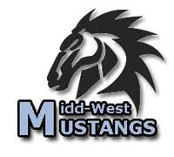
Midd-West School District
Solar Array
Will Power 100% of District’s Electricity Needs

Two solar arrays totaling 7.25 acres will save the district close to $9 million in electricity costs over 40 years, insulate it from energy cost inflation, and create educational opportunities for its students.

The Midd-West School District in Middleburg, PA, completed a 2.56 MW (megawatt) solar project in November of 2020 that will generate 100% of the district’s electricity. The array will save the district close to $9 million over the 40-year life of the system. The project was a partnership between the district, Solar Renewable Energy, LLC, of Mechanicsburg, and GreenWorks Development, LLC, of Harrisburg.

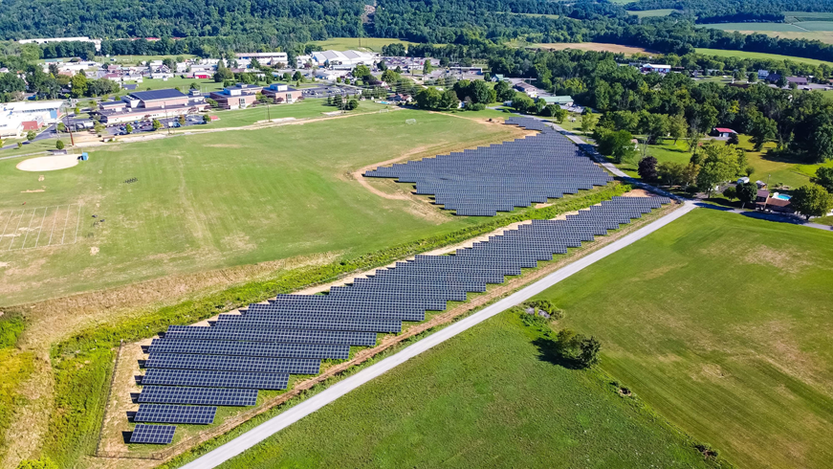
The main array was installed on 6 acres of land behind the main school complex and athletic fields at 10 Dock Hill Road in Middleburg. A 1.25-acre array was also installed behind the football field at West Snyder Elementary, 645 Snyder Avenue in Beaver Springs to power that building. A total of over 6,500 panels were installed at the two sites.
Primary Array behind Main Campus

No up-front investment on the part of the district was required because of the financial structure brought to the project by Solar Renewable Energy, LLC and GreenWorks Development. With no up-front investment, the district will start saving in year one, and will continue saving each year over the 40 year expected useful life of the array. The district’s electricity cost will remain fixed at a projected average of $0.037/kWh for that entire period, a significant advantage for Midd-West.

Rick Musselman, District Superintendent, is excited about Midd-West’s solar project both for the district and its students. “The electricity savings have been exactly as we expected since the startup of the system. The district will save significant money over the life of the system and our electricity costs are now fixed for the next 40 years. In addition to the savings, our science department is using the data from the array to teach our students about solar and compare it to other energy sources,” he said. “The system has met and exceeded all of our expectations.”

The district receives power generation data from the system every 15 minutes, and science classes are using that information to investigate solar performance on a daily and seasonal basis. The solar industry is one of the fastest growing segments of the US economy and students now have direct experience with cutting edge energy technology to take with them in their future career decisions.

The cost of solar has decreased dramatically over the last ten years, and solar and wind are now the least expensive ways to produce electricity across most of the US. Midd-West School District has taken advantage of the low cost of solar generation and has given its students first-hand experience in renewable energy that will benefit them for the rest of their lives.

Contact:
Doug Neidich
GreenWorks Development
717.514.0751
dneidich@greenworksdev.com

